HTML Image Tag

**HTML Images** are defined within **<img> tag**. **Image tag** or **<img>** is a unpair element. src and alt attributes are used to add properties to image.

HTML includes **image tag** from its 4th version **(HTML4)** ie since 1997. Images enhance the look and feel of a website. We uses images as a **logo**, **banner**, **icons**, **symbols**, **product** etc.

### **How to insert image in html**

<img src="" alt="">

HTML Images Formats and Comparision

Html supports four popular images extensions, jpg, png, gif and svg.

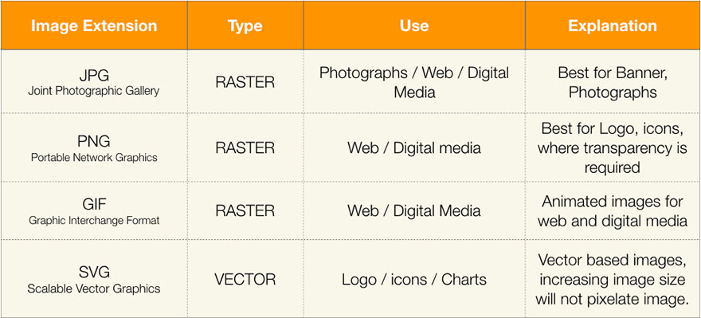

## Image Attributes

|  |  |
| --- | --- |
| **Attribute** | **Use** |
| src | **source or path of image** ( compulsory ) |
| alt | **alternate text** for image ( compulsory ) |
| title | show tooltip on mouse over |
| width | control width of an image |
| height | control height of an image |

## Alt Attribute

**alt attribute** is the compulsory attribute for image tag. It helps google and other search engines to search images in search results. If in any case image fail to upload, alt text hold the space and tell user about image.

### **What happen if src is invalid in image?**

alt attribute

<img src="img/logo" alt="Tech Altum Logo">

**alt attribute** is compulsory, but value of alt can be blank.